Exercises Lab06

Booleans

Look at the Robot’s API to see what boolean methods might be helpful here.

|  |  |
| --- | --- |
| 1. Write the commands to force a Robot object named karel to face west no matter what direction it is initially facing.  **while(!karel.facingWest()) {  karel.turnLeft();  }** | 2. Write the commands to make an Athlete named ann to put down all her beepers.  **while(ann.hasBeepers()) {**  **karel.putBeeper();**  **}** |
| 3. Write the commands for Climber c to pick up a pile of beepers.  **while(c.nextToABeeper ()) {  c.pickBeeper(); }** | 4. Write the commands for Racer ray to stop moving when it is next to (on top of) another robot.  **while(!ray.nextToARobot ()) {  ray.move(); }** |

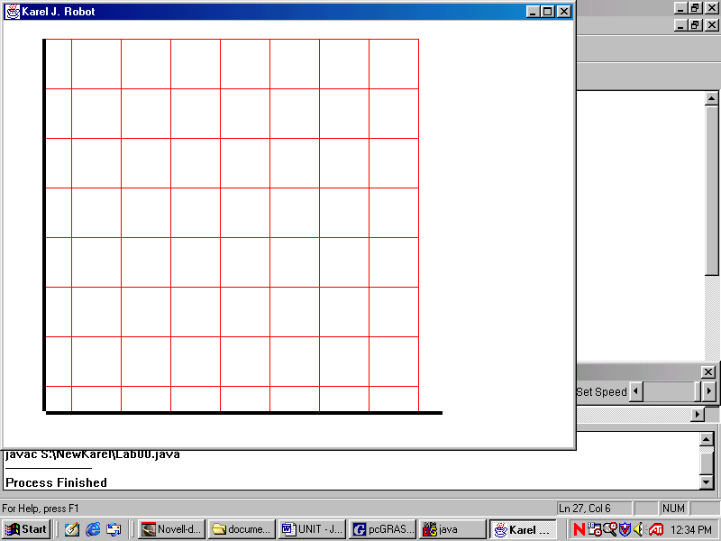5) Given the declarations and the default map, indicate the boolean value of each statement.

Robot pete = **new** Robot(5, 1, Display.WEST, 37);

Robot lisa = **new** Robot(2, 6, Display.SOUTH, 0);

|  |  |  |
| --- | --- | --- |
| !pete.frontIsClear() | true | **false** |
| pete.hasBeepers() | **true** | false |
| !lisa.hasBeepers() | **true** | false |
| !pete.facingWest() | true | **false** |
| lisa.facingWest() | true | **false** |

6) The logical AND (in Java) is the symbols &&. The logical OR (in Java) is the symbols||. Evaluate:

|  |  |  |  |  |  |  |
| --- | --- | --- | --- | --- | --- | --- |
| true && true | 🡪 | True |  | true || true | 🡪 | True |
| true && false | 🡪 | False |  | true || false | 🡪 | True |
| false && true | 🡪 | False |  | false || true | 🡪 | True |
| false && false | 🡪 | False |  | false || false | 🡪 | False |

7) Extra Credit: make a truth table that shows that De Morgan’s Laws are true:

!(a && b) == !a || !b !(a || b) == !a && !b

DONE IN CLASS